[55958- Aman Goswami, Documentation – 3, Date- 11 Dec 2025]
Q- IP Address, Subnet, and NAT
1. What is an IP Address?
An IP address (Internet Protocol address) is a unique numerical identifier assigned to each device connected to a network.
It helps devices identify and communicate with each other over the internet or a local network.
Example:
192.168.1.10
Just like a home address helps in delivering letters, an IP address helps in delivering data to the correct device.
Types of IP Address
Public IP Address
A Public IP address is assigned by the Internet Service Provider (ISP) and is used to identify a device on the Internet.
- Accessible over the internet
- Must be unique worldwide
- Used by websites, servers, and routers
Example:
8.8.8.8
Private IP Address
A Private IP address is used within a local network (home, office, college).
- Not accessible directly from the internet
- Can be reused in different networks
- Used by internal devices like laptops, mobiles, and printers
Common Private IP ranges:
- 192.168.0.0 – 192.168.255.255
- 10.0.0.0 – 10.255.255.255
- 172.16.0.0 – 172.31.255.255
Example:
192.168.1.5
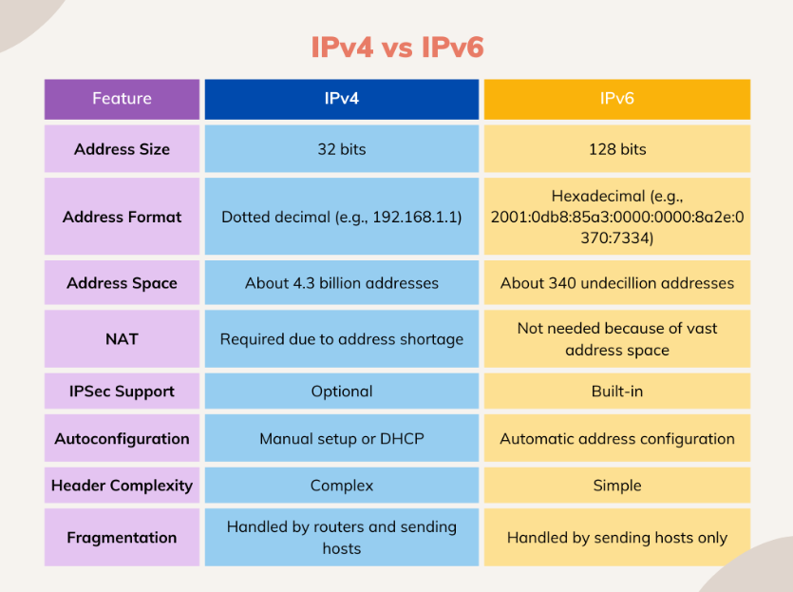
2. What is a Subnet?
A Subnet (Sub-network) is a smaller network created by dividing a large network into smaller parts.
It helps in better network management, security, and performance.
Why is it used:
- Reduces network traffic
- Improves security
- Makes IP management easier
Example:
If a network has IP range:
192.168.1.0/24
It can be divided into multiple subnets for different departments, like:
- Admin
- Development
- Testing
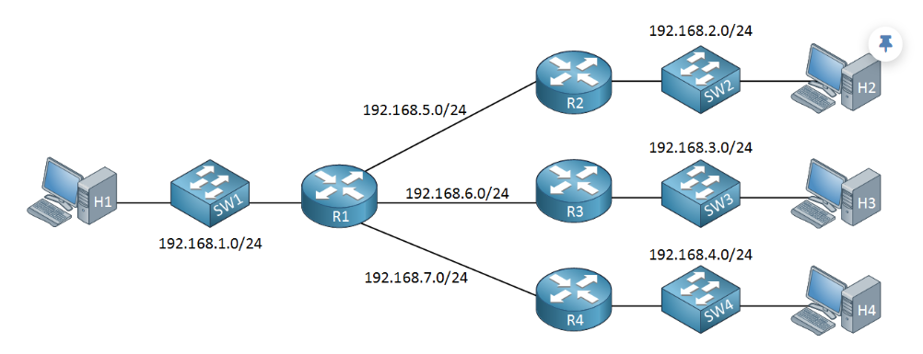
3. What is NAT (Network Address Translation)?
NAT is a technique used by routers to translate private IP addresses into public IP addresses and vice versa.
Why NAT is needed:
- ISP provides only one public IP
- Many devices need internet access
- NAT allows multiple devices to share a single public IP
How NAT works (simple example):
- Laptop → 192.168.1.10 (private IP)
- Router → Converts it to a public IP
- Internet → Sends response back to router
- Router → Forwards it to the correct device
Real-Life Example of NAT
At home:
- Phone → 192.168.1.2
- Laptop → 192.168.1.3
- TV → 192.168.1.4
All devices use one public IP provided by ISP.
This is possible because of NAT.
